SMS API

✅ What is an SMS API?
# Source: Chatgpt (GPT-5-Mini) at [1/19/2026]
An SMS API is a programmatic interface (usually REST-based) that allows your application or website to send, receive, and manage SMS (text) messages through an SMS gateway provider.

🔹 What Can an SMS API Do?
# Source: Chatgpt (GPT-5-Mini) at [1/19/2026]
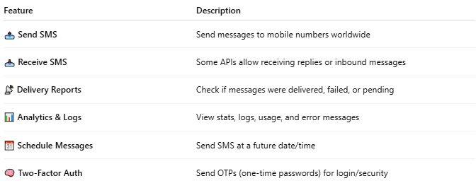

Feature | Description
📤 Send SMS | Send messages to mobile numbers worldwide
📥 Receive SMS | Some APIs allow receiving replies or inbound messages
📡 Delivery Reports | Check if messages were delivered, failed, or pending
📊 Analytics & Logs | View stats, logs, usage, and error messages
📆 Schedule Messages | Send SMS at a future date/time
🧠 Two-Factor Auth | Send OTPs (one-time passwords) for login/security

🔸 Popular SMS API Providers
# Source: Chatgpt (GPT-5-Mini) at [1/19/2026]
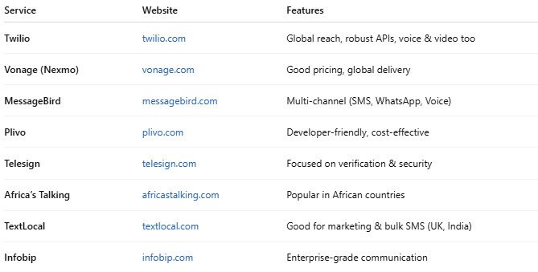

Service | Website | Features
Twilio | twilio.com | Global reach, robust APIs, voice & video too
Vonage (Nexmo) | vonage.com | Good pricing, global delivery
MessageBird | messagebird.com | Multi-channel (SMS, WhatsApp, Voice)
Plivo | plivo.com | Developer-friendly, cost-effective
Telesign | telesign.com | Focused on verification & security
Africa’s Talking | africastalking.com | Popular in African countries
TextLocal | textlocal.com | Good for marketing & bulk SMS (UK, India)
Infobip | infobip.com | Enterprise-grade communication

📦 Sample API Request (Twilio)
# Source: Chatgpt (GPT-5-Mini) at [1/19/2026]
POST to:
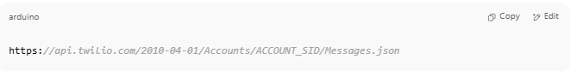
https://api.twilio.com/2010-04-01/Accounts/ACCOUNT_SID/Messages.json

With form data:
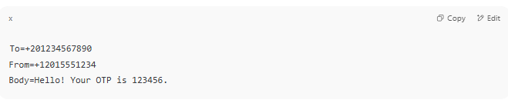
To=+201234567890
From=+12015551234
Body=Hello! Your OTP is 123456.

Authorization: Basic Auth with ACCOUNT_SID:AUTH_TOKEN

📌 Free & Trial Options
# Source: Chatgpt (GPT-5-Mini) at [1/19/2026]
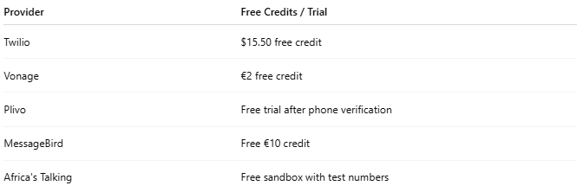

Provider | Free Credits / Trial
Twilio | $15.50 free credit
Vonage | €2 free credit
Plivo | Free trial after phone verification
MessageBird | Free €10 credit
Africa's Talking | Free sandbox with test numbers

📲 Common Use Cases
# Source: Chatgpt (GPT-5-Mini) at [1/19/2026]
- ✅ OTP verification (login, signup)
- ✅ Marketing and promotional campaigns
- ✅ Appointment reminders
- ✅ Transaction alerts (bank, e-commerce)
- ✅ 2FA for app security

